The Smooth Tool

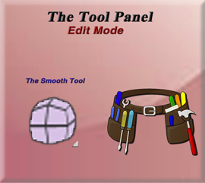

Even though Blender offers this Smooth tool in its Edit mode tool box, it is probably not the best way of going about this smoothing process. As Blender offers more efficient ways of smoothing, through both it Object’s mode right click menu, and through modifiers such as the Subdivision Surface modifier and the Laplacian Smooth modifier. But that being said, since this is a topic in this Blender series on the Edit mode’s tools panel, and this tool is offered here, it doesn’t mean I will not be talking about it. So, in this tutorial I will be presenting the Smooth tool, and its techniques for using it.

The Default Cube

Go into Edit Mode with the default cube. Now if you attempt to use this Smooth tool on it, you will quickly notice that it really doesn’t work so well. If you select the entire box, it will only make the cube larger or smaller. And grabbing just a vertex won’t really do too much either.

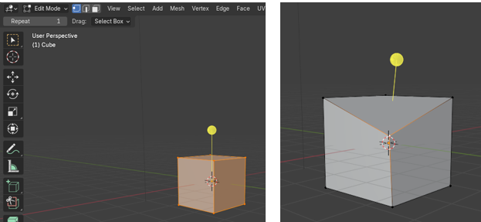

This is because of vertex count right now on the cube; in order to smooth we really need to subdivide this cube to make the mesh more malleable.

So, what we really need to do is to Sub divide this cube, by selecting the cube and right clicking to bring up this menu.

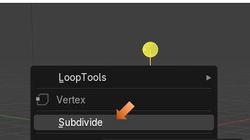

I upped the number of cuts to 10, so we really have something to work with. Take note that there is also an option for Smoothness from this dialog box too.

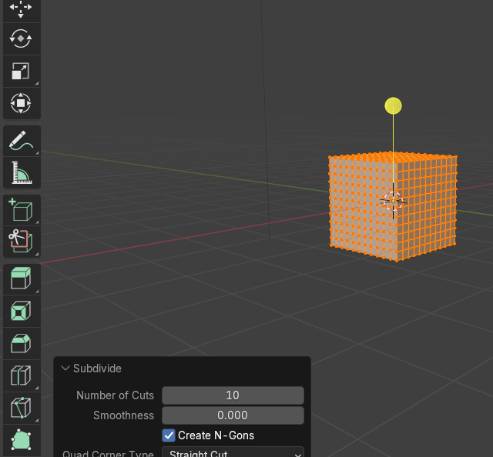

This is what Smoothness would look like if we by passed the smooth tool, and upped the smoothness in the last Operation Subdivide box.

Move it to 1 from this box and we get a perfect ball

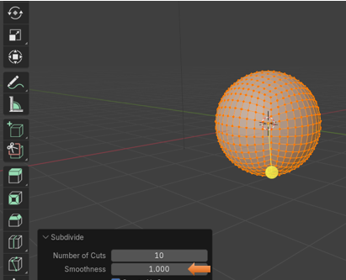

Now Ctrl-Z to undo that and try the Smoothness tool from the Tool box instead. You will find that if we use the Tool, and set the smoothness to 1, we get this.

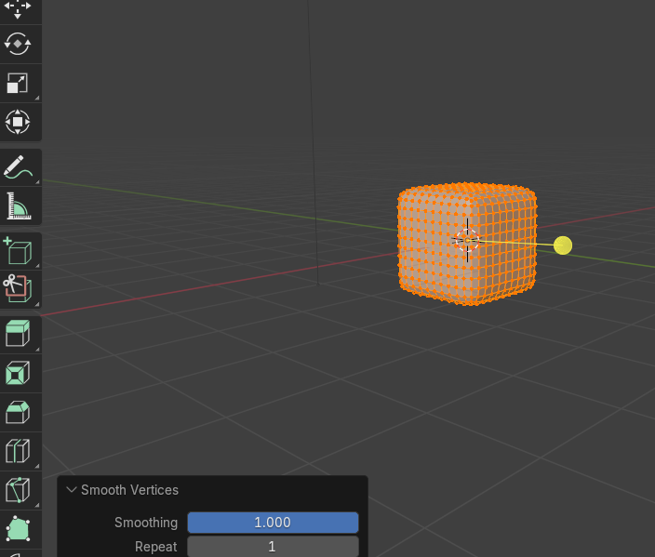

Now if we try to up the Smoothness level, we actually get a mess with parts of the mesh sticking through other sections of the mesh.

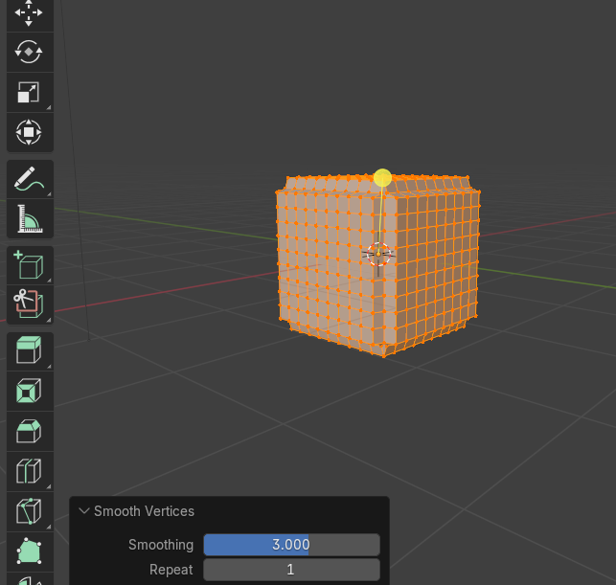

If we up the Repeat to something like 10, we find that the cube will actually shrink to try and get somewhere.

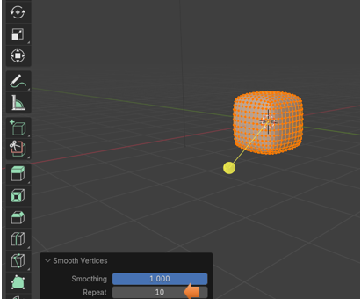

Here we up the Repeat to 50. Still not quite a round ball. But if all you want is to round the corners on this cube, it works fairly well.

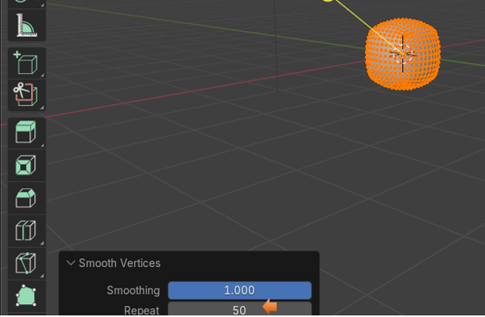

# Smoothing Specific Axis

You can also decide to just smooth certain axis on your object, by checking and unchecking the Axis boxes at the bottom of the Smooth Vertices dialog box. Here I turned off the X axis, and so it did not smooth on that axis.

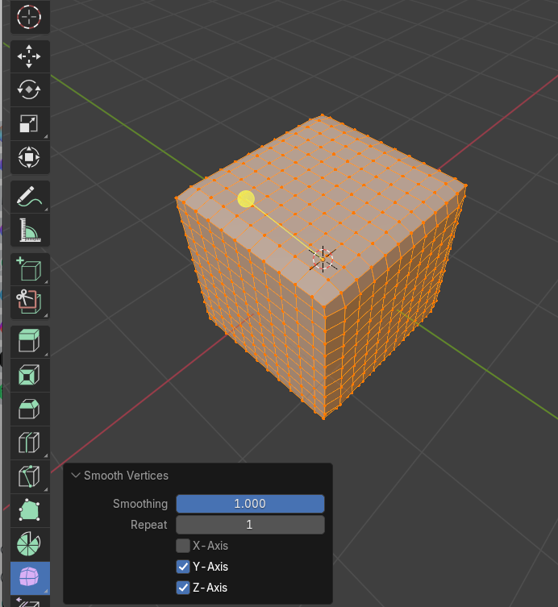

This was just a really short tutorial, because as I said this tool probably isn’t the best for this smoothing task, but it is available to you if you want to use it.